Anatomy of the Respiratory Tract
Institutional affiliation
Name of lecturer
Name of student
Submission date
Anatomy of the Respiratory Tract
Introduction
The respiratory system consists of the patent upper way (upper respiratory tract) and the lower respiratory tract. The upper respiratory system consists of the nasal cavity and the sinus, oral cavity, pharynx, and larynx. This paper will review the patent upper way from the external nares to the larynx and pharynx. The patent upper away opens to the external environment in the nose and the mouth and extends to the trachea. It allows the passage of gases to and from the environment to enable gaseous exchange in the lungs. The respiratory system process allows the body to acquire oxygen used by body cells and organs and eliminate poisonous gases such as carbon (IV) oxide. The mouth is used in breathing during exercise and reduces resistance to gas flow in the external nares.
Functions of the patent upper way include;
It gives a passageway for gas flow, filters gases as they enter the lower respiratory tract, acts as a heater and humidifier of gases. It is the sense organ for smell and taste, phonation and protects the lower airways. The gases in the environments contain particles, which may injure the more inadequate respiratory systems, and thus it is cleaned, heated, and moisten by the patent upper way. This way, the gases are safe and can be used in the body.
Patent upper way
This opens to the environment through the external nares or the nostrils and mouth. It consists of the nasal cavity and sinus, oral cavity, pharynx, and larynx.
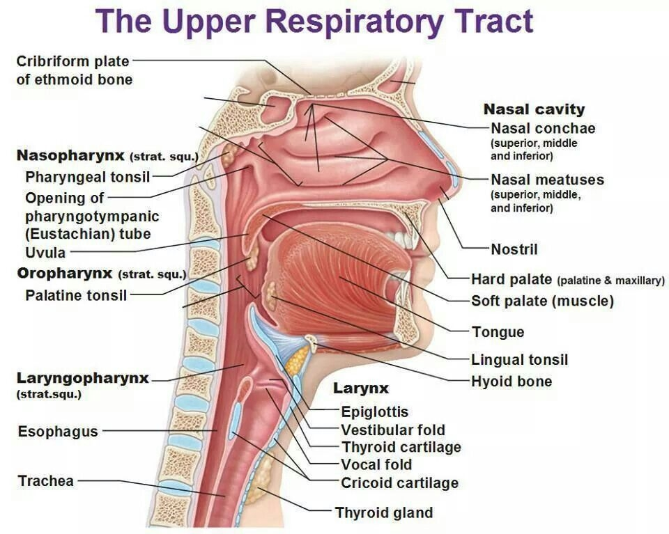
Nasal cavity and sinuses
This is formed by two flared openings of external nares called alae. The alae form paces that contain hairs called the vestibule. This acts as a filter to the gases entering the respiratory tract and ensures they are clean and safe from particles from the environment. The anterior nares (left and right nasal cavities) are made of skull bones and cartilage. The two nasal cavities are separated by a septum and are formed by cartilage, ethmoid, and vomer bones. Also, they contain maxilla, palatine, and lacrimal bones in their walls, while maxilla bones primarily form the cavity. It contains three shelf-like bones that protrude into the cavity from the lateral walls and are called the turbinate bones. This acts as the humidifier, heater, and filter of air as it enters the respiratory tract.
The turbinates or the conchae increase surface area in the nasal cavity to enable moistening of air, heating, and filtration of the inhaled gas. The internal nares are formed and covered by epithelial cells and stratified squamous cells. These cells contain hair follicles ad hair that act as filters of the inhaled air. The stratified squamous cells are the same as the epidermis cells found on the skin. Also, it contains ciliated pseudostratified epithelial and goblet cells that secrete mucus. This also facilitates humidification, filtration, and heating of inhaled gases. Any infection to these cavities leads to inflammation and vasodilation, leading to vessel leakage and nose bleeding.
Oral cavity
This is an opening that allows respiratory gases to enter and exit the respiratory tract. It is the space between the lips and the hard palate. The roof of this region is the hard palate and is formed by maxillary born. It also has the soft palate's posterior portion that can move up and down to seal the nasal cavity. The cheeks make the walls of the oral cavity, and the tongue dominates the base. The uvula or the soft palate controls the flow of air in and out of the respiratory tract. Also, it prevents the entry of fluids and food into the respiratory tract. The tongue is involved in digestion, phonations taste.
Functions of the oral cavity
The oral cavity produces saliva, which is produced by major and minor salivary glands. Although the primary use of saliva is indigestion, it acts as a humidifier of the gases as they enter the respiratory tract. Also, it serves as the heating surface of the air, but it is less effective than the nose. This cavity ends at the palatine folds, and this part plays an important immunologic role in children. In addition, the reflexes of the mouth, larynx, and pharynx protect the inner respiratory tract (the lower respiratory tract). The oral cavity is mainly used in gaseous exchange during exercise as the body requires large amounts of oxygen, which may not be sufficient if the gaseous exchange is done through the nose.
Pharynx
This is the posterior portion of the nasal and oral cavities. It is lined with stratified squamous epithelium. It is made up of the hypopharynx, oropharynx, and nasopharynx. This portion of the respiratory tract contains thicker epithelium than any other part of the respiratory tract to protect the tissues from chemical and mechanical injury caused by food. The pharynx acts as a passageway for food into the stomach and air in the lower respiratory tract (lungs). Longitudinal and circular muscles facilitate this function in the pharynx that works together to ensure food and drinks are directed to the stomach. At the same time, the air is channeled to the lower respiratory tract.
The nasopharynx lies in the posterior end of the nasal cavity and extends to the uvula. It contains two pharyngeal tonsils that monitor and interact with particles in the inhaled air. Also, it contains the right and left Eustachian tubes that act as a link between the upper airway and the middle ear. These tubes allow air to move in or out and balance the pressure on both sides of the tympanic membrane. The oropharynx extends to the oral cavity and the uvula, and the upper rim of the epiglottis. The region contains a pair of palatine tonsils that can become swollen, causing partial blockage of air. Finally, the hypopharynx or the laryngopharynx extends to the upper rim of the epiglottis and the vocal cords. This portion changes speech and swallowing.
The larynx
This lies below the hypopharynx and is formed by nine complex membranes and muscles. It is also called the voice box. This portion of the patent upper way protects the lower respiratory tract during himation, eating, and drinking. The primary function of the larynx is to facilitate and is essential in phonation. The Adam’s apple or the thyroid cartilage forms most of the upper part of the larynx. Below it is the cricoid cartilage, and it's the only cartilage that includes a complete ring. The base and back of the tongue form the inlet of the larynx when viewed with a laryngoscope. The vallecula is folds formed between the tongue and the epiglottis and are a vital landmark in oral intubation.

References
Kacmarek, R. M., Stoller, J. K., & Heuer, A. J. (2021). Egan’s fundamentals of respiratory care (12th ed.). Elsevier.

